**Lab_** **Day-14 (Tuples)**

1.Write a python program and iterate the given tuples Input: employee1 = ("John Doe", 101, "Human Resources", 60000) employee2 = ("Alice Smith", 102, "Marketing", 55000) employee3 = ("Bob Johnson", 103, "Engineering", 75000)

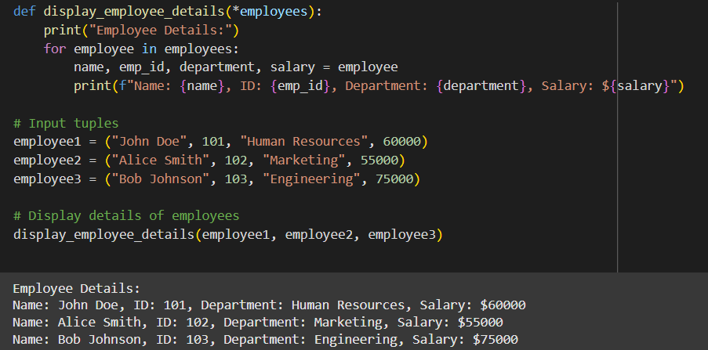

2.Write a Python program to convert a list to a tuple.

Input: listx = [5, 10, 7, 4, 15, 3]

